Sunlit Sea Progress Report
We are sending an update to our shareholders regarding Sunlit Sea’s latest progress and future plans. Since our last progress report, we have made significant strides in both business development and technology. In this update, we will share news about key projects, partnerships, capital raising, and the progress of our next-generation product, V2.
We are in an exciting phase, with new contracts signed and strategic opportunities that will strengthen our position as a leading player in floating solar energy. At the same time, we want to highlight some important milestones that will help secure the company’s liquidity and future growth.
Thank you for following our progress, and we look forward to continuing to build Sunlit Sea together with you.
Please note: Information about capital raising is available at the end of this update.

Business Model
We have established a portfolio of projects and defined a three-part business model:
- Direct Sales: Direct sale of floating solar panels to project developers or end users, either directly or through partners. No recurring revenue.
- Develop-Operate-Sell: Develop or invest in projects, negotiate Power Purchase Agreements (PPA), operate for 1-2 years, and then sell the project. This generates recurring revenue until the installation is sold and typically results in a higher sales price compared to direct sales.
- Licensing: Licensed production and distribution under other brands, such as through Emrgy.
The latest addition to our business model is licensed production, which we are exploring together with Emrgy (more on this below).

Projects
Our project portfolio includes the following:
Project | Country | Buyer | Model | Product | Size | Revenue | Status | Delivery date
Mannheim Cablepark | Germany | Rixen | Direct sales | V1 | 60 kW | €110,000 | Delivered | 2023.08.01
Haugaland Næringspark | Norway | SPV | Develop-operate-sell | V1 | 105 kW | €180,000 | Constructing | 2024.10.10
Magdeburg Cablepark | Germany | Rixen | Direct sales | V1 | 60 kW | €110,000 | Constructing | 2024.12.10
Oregon Canal Pilot | USA OR | Emrgy | Licencing | V1 | 50 kW | €50,000 | Constructing | 2025.04.01
Haugaland Næringspark | Norway | SPV | Develop-operate-sell | V1/V2 | 1 MW | €1,000,000 | Permitting | 2025 Q2
Eden Project | UK | Custom Solar | Direct sales | V2 | 100 kW | €150,000 | Permitting | 2025 Q2
Roskilde pilot | Denmark | COWI | Direct sales | V1 | 30 kWp | €50,000 | Permitting | 2025 Q2
Water reservoirs pilot | Portugal | University of Evora | Direct sales | V1 | 300 kW | €450,000 | Prefeasibility | 2025 Q3
Dynea Lillestrøm | Norway | Østfold Energi | Direct sales | V2 | 500 kW | €500,000 | Prefeasibility | 2025 Q3
Larnaca Offshore | Cyprus | Scandinavian Solar Parks | Direct sales | V2 | 490 kW | €490,000 | Prefeasibility | 2025 Q4
Nearshore Fish Farms | Chile | Innovex | Direct sales | V2 | 100 kW | €100,000 | Prefeasibility | 2025 Q4
Oregon Canal Commercial | USA OR | Emrgy | Licencing | V2 | 1 MW | €1,000,000 | LOI | 2026 Q1
Oyten Cableway | Germany | Rixen | Direct sales | V2 | 827 kW | €1,310,000 | Feasibility | 2026 Q2
Hærøya Industripark | Norway | SPV | Develop-operate-sell | V2 | 3 MW | €2,500,000 | Prefeasibility | 2026
US Canal FPV Scaleup | USA CA /OR/WA/ID | Emrgy | Licencing | V2 | 10 MW | €7,500,000 | LOI | 2026-2028

Explanation:
- Model indicates the business model under which the project is being developed.
- Status refers to the project's current maturity, where constructing means agreements have been signed or there are strong indications that the project is imminent.
- Product refers to either V1 (our current product) or V2 (our upcoming product).

Rixen (Magdeburg)
Since our last update, we have signed our second project with Rixen Cableway (Magdeburg), demonstrating that we have built strong trust with the customer through our first installation. This has laid the foundation for a recurring partnership, with Rixen actively working on several projects on our behalf, particularly in Germany and France. We have also secured a staggered payment agreement for the Magdeburg project, which ensures steady cash flow during production. Rixen has a comprehensive project portfolio in floating solar, with several projects in the pipeline.
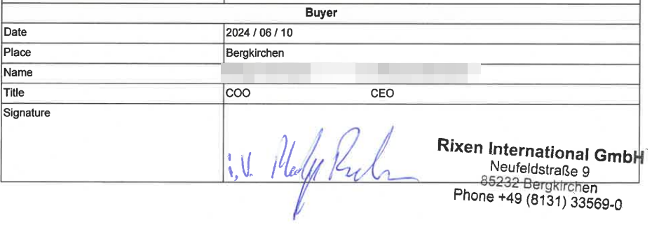

Haugaland Næringspark
We are currently installing our Enova-supported project (105 kW) on October 10, after delays due to shipping issues from China. This project is our first under the “develop-operate-sell” model, where we sell electricity through a PPA with EV Powercharge. Strategically, this project is vital as Haugaland Næringspark has significant potential for further floating solar expansion.
Skiftestjørna, where we are installing 105 kW, has the capacity to be expanded to 1 MW. The grid currently has limited capacity, but expected regulatory changes in 2025 allowing direct solar power sales between neighbors could significantly boost expansion. Additionally, there is an enormous potential for up to 40 MW of floating solar in the area, which we are actively discussing with Haugaland Næringspark and the local municipality. This could become one of the largest floating solar installations in Norway, and we have already started dialogues with potential power buyers and investors.
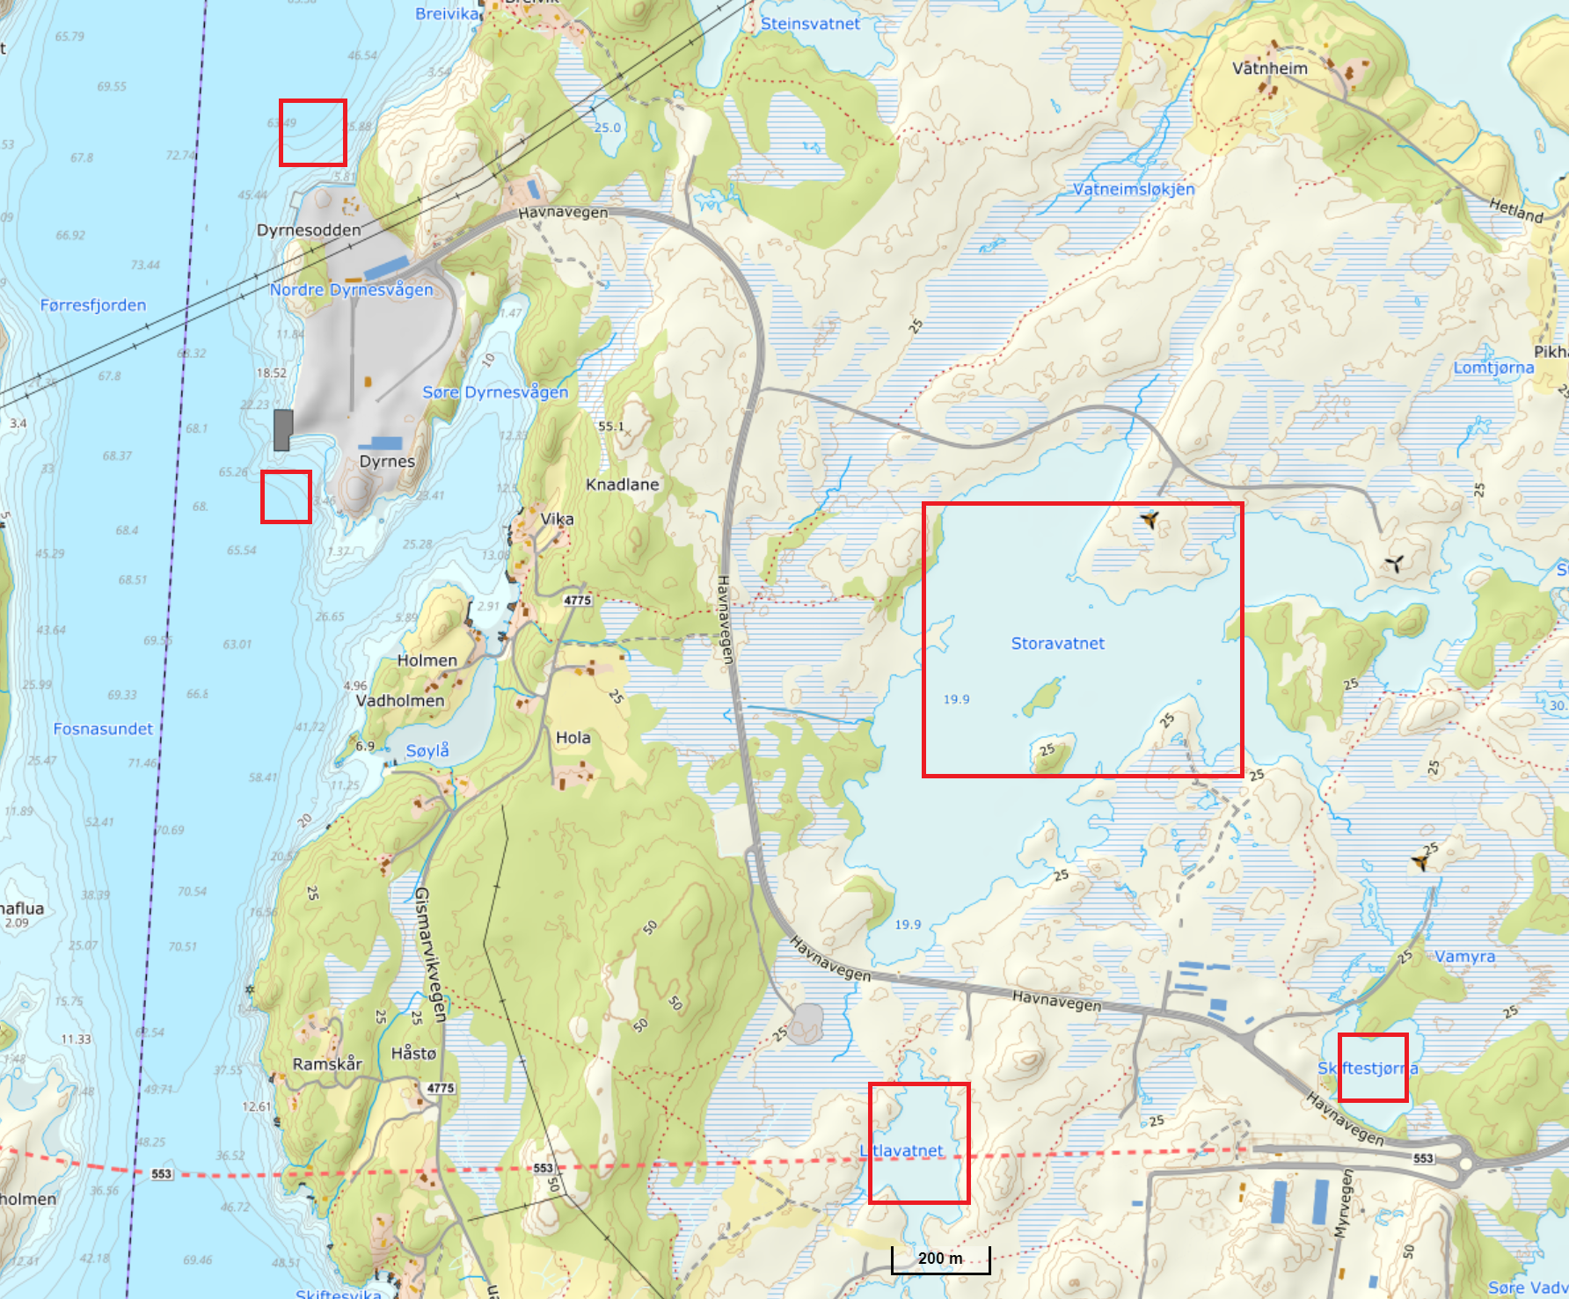

Emrgy Licensing Agreement
We are in the final stages of negotiating a licensing agreement with Emrgy, covering the production and distribution of our V2 product in U.S. canals. The agreement ensures that Emrgy commits to ordering our products in stages of 50 kW, 250 kW, and 700 kW as we reach key milestones in V2 development. This provides a clear path forward while showcasing Sunlit Sea’s product in the U.S. market.
The agreement also opens doors for us to deliver solutions for hydropower plants, inland water bodies, and nearshore areas, giving us a strategic position in this growing segment. As part of the licensing agreement, Sunlit Sea will receive a share of Emrgy’s project revenues, an aspect we are currently negotiating. This collaboration will strengthen our presence in the U.S. market and create new revenue streams for the future.

Soft Funding
As mentioned in the previous update, we have received a €500,000 grant from the EU for the SuRE project, of which 75% has already been disbursed. This has bolstered our liquidity, which is crucial for maintaining momentum in the development of our V2 product. The SuRE project aligns with our commercial goals, focusing on the development of floats and water sealing for V2.
We were not awarded funding from Pilot-E, but we received positive feedback on a new application to Eurostars, where we have a high probability of receiving €500,000. To secure this funding, we must document positive equity by the deadline of October 8, making the ongoing capital raise essential. This equity round is necessary to secure the funds we have applied for.
We have resumed dialogue with Innovation Norway and are considering two support programs: Innovation Contract (with Emrgy) and Environmental Technology (for V2). We have a meeting on October 7 to receive advice on which application to pursue.

Next-Generation Product (V2)
The development of our V2 product is a key milestone for Sunlit Sea. V2 will use standard solar panels, which will significantly reduce costs from the current €1,100 per kW with V1 to approximately €250 per kW with V2. This will give us a competitive advantage in larger projects and increase margins on smaller projects.
We have a targeted development plan for V2 over the next six months, with multiple parallel workstreams to ensure rapid progress. The total cost to complete V2 is estimated at €1 million. Of this, €350,000 is already secured through support from the SuRE and Surewave projects. We are also undergoing financial qualification to receive €500,000 from Eurostars, which will directly support V2 development. Project financing from existing and new contracts, including the Emrgy agreement, will further support this development to ensure that all aspects of the product are completed on time.
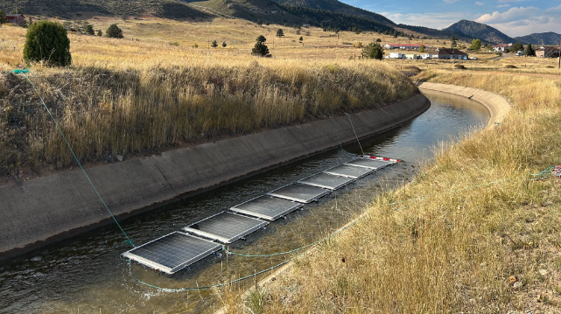

Growth Strategy
With the launch of our next-generation product, V2, Sunlit Sea is poised for significant growth. V2 will enable us to offer a price per kW that is competitive with the cheapest solutions on the market, while also offering robustness that exceeds existing competitors in the nearshore segment, such as Ocean Sun and Oceans of Energy.
Another key competitive advantage is that there are currently no other solutions on the market designed for flowing water, a segment where Emrgy, our partner, has tested solutions from other competitors without success. This makes Sunlit Sea uniquely positioned to deliver solutions that meet the demands of this segment, giving us a competitive edge in fast-growing markets such as the U.S.
To realize the development and delivery of V2, we plan to hire two engineers in the short term to strengthen our technological development capacity. This is crucial for ensuring that we complete product development and meet milestones in collaboration with Emrgy.
As we approach the launch of V2 and more projects are realized, we will gradually expand our production team by hiring additional staff. This growth will be aligned with increasing demand, ensuring that we can meet delivery targets for both existing and future projects without overburdening the organization. This also lays the foundation for further scaling in line with market growth.

Liquidity Situation
As of October 1, 2024, Sunlit Sea AS has a balance of over NOK 4 million, including the recently received grant from the EU for the SuRE project. This grant has significantly bolstered our short-term liquidity. Without this support, the liquidity situation would have been much more constrained.
Our estimated burn rate based on current operations (status quo) – where we only deliver on existing V1 projects without further development toward V2 – is approximately NOK 160,000 to 210,000 per month. This variation is partly due to project income timing and some cost-saving measures that have already been implemented.
With this burn rate and a balance of just over NOK 4 million, we have enough liquidity to maintain operations for approximately 18-24 months, assuming we continue operating at the current level without a significant increase in expenses or investments.
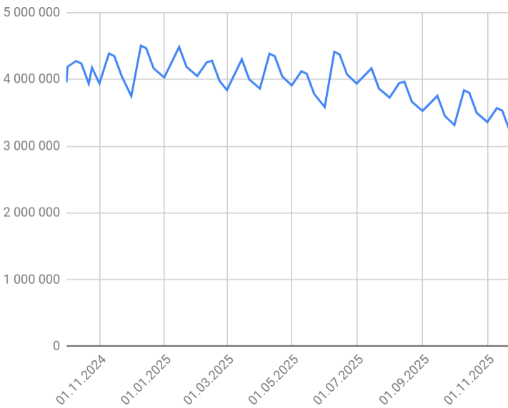 | 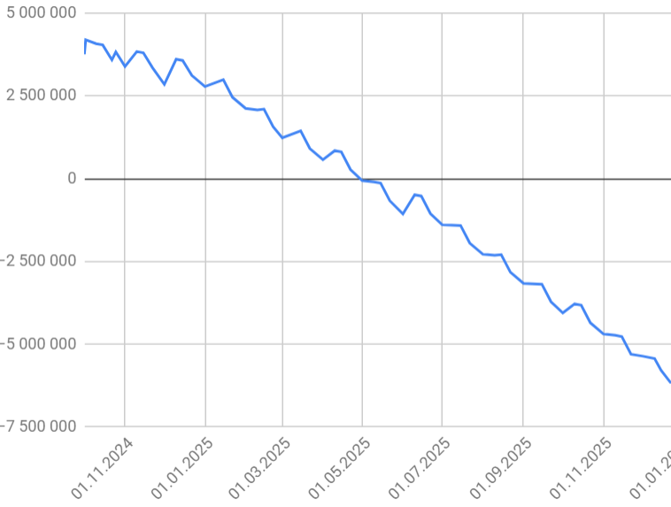 | 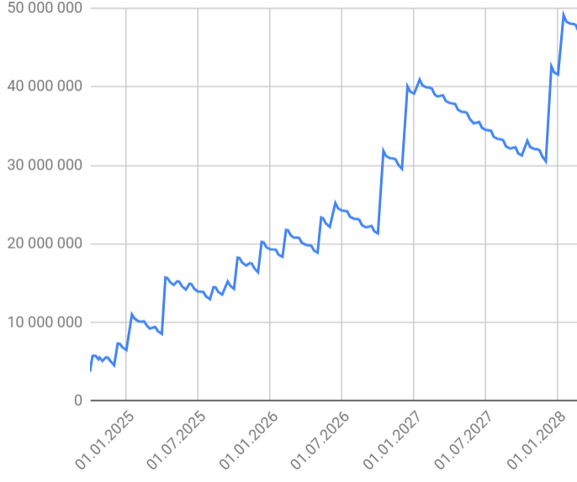
Figure 1:  No new projects, only deliveries secured at present with V1. | Figure 2:  No new projects or financing, deliveries secured at present with V1, full development of V2 in parallel. | Figur 3:  Figur 3:  Nye prosjekter med V1 og V2, finansiering av V2, utvikling av V2.

Financial History and Results
Sunlit Sea AS has demonstrated significant growth in its R&D investments over the past few years, while also undergoing a development phase with high costs related to product development. Below is a summary of the company’s financial results over the past four years:
- 2020:
  - Revenue: NOK 4.8 million (mainly public grants).
  - Expenses: NOK 9.75 million, primarily related to salaries and prototype development costs.
  - Net Result: NOK -4.93 million.
  - Equity: NOK -0.37 million.
- 2021:
  - Revenue: NOK 174,000 (mainly from R&D).
  - Expenses: NOK 3.74 million, with salary costs of NOK 2.11 million.
  - Net Result: NOK -3.64 million.
  - Equity: NOK 8.8 million, supported by share premium and other equity of NOK 12.8 million.
- 2022:
  - Revenue: NOK 483,600 (from sales).
  - Expenses: NOK 6.25 million, with a large portion of R&D depreciation and salary costs.
  - Net Result: NOK -5.82 million.
  - Equity: NOK 2.98 million, after significant investment in R&D projects, with capitalized R&D value of NOK 21.35 million.
- 2023:
  - Revenue: NOK 2.1 million, a notable increase from 2022 due to higher sales.
  - Expenses: NOK 8.88 million, with a reduction in cost of goods sold but still high salary and depreciation costs.
  - Net Result: NOK -7.17 million.
  - Equity: NOK -2.63 million, with continued investment in development projects, capitalized at NOK 18.89 million.
Sunlit Sea has made significant investments in research and development, particularly related to its current product, V1, which is also applicable to the R&D of the next-generation product, V2. These investments have resulted in increased losses in recent years, but have also strengthened the company’s technological platform, goodwill in the research community, and market position. Given the high capitalized value of development costs, it is important for investors to note that future revenues largely depend on the commercialization of these investments.

Capital Raise
Sunlit Sea is conducting a directed share issue to strengthen equity and secure qualification for support from Eurostars, which can provide us with a €500,000 grant. The issue aims to raise NOK 4,000,000, and we already have commitments from KodeWorks for NOK 2,000,000 and from Kamin Eiendom for NOK 720,000. This means we still need NOK 1,280,000 to reach the issue target.
It is critical that we reach this target to secure further financing for the development of our V2 product and the execution of our strategic projects. The subscription deadline is set for October 7, and this date cannot be extended as it is tied to the reporting deadline for our financial qualification with Eurostars.
We therefore encourage all shareholders to notify us if they wish to participate in the share issue or if they have any questions regarding the presented information. Please also feel free to share this opportunity within your network if you know of potential investors who may be interested. For more information on terms and details, please see the attached subscription form and investor memorandum.

